Auckland House Prices Analysis

Harshil Shah

2020

Executive summary:

The data set is the Auckland house price dataset, which contains all the essential details of the different house measurements.

The analysis is based on 1051 observations for each of the 15 variables. The response variable is capital value (CV) of the house. The rest of the variables are mostly explanatory variables for the specific house, but only a certain few a relevant in making the model.

After exploring the data by calculating summary and descriptive statistics and creating visualizations of the correlation between each numerical variable, several high correlated variables are found. After exploring the data, a logistic regression was applied.

Initial data exploration:

The initial exploration of the data began with some summary and descriptive statistics. Individual Feature Statistics Summary statistics for minimum, maximum, mean, median, standard deviation, and distinct count were calculated for numeric columns, and the results taken from 216 observations are shown here:

Correlation and relationship:

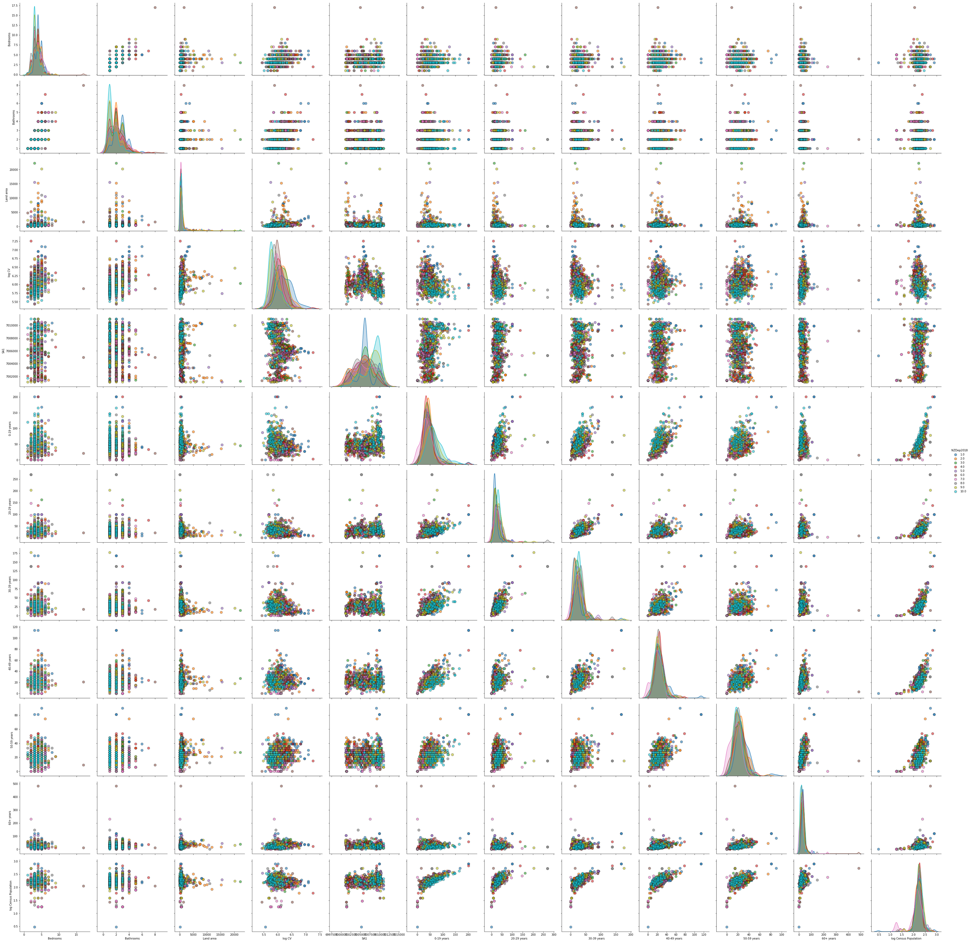

The correlation between the numeric columns were calculated and observed in the below correlation plot. The plot shows that bedrooms and bathroom have good correlation. The pairs plot graph is grouped into decile. The log census population also have good correlation with the age group variables.

The correlation matrix shows more accurately how much the variables are correlated. The lighter colored squares are highly correlated with the corresponding variable.

Analysis:

First, a regular linear model was made, and wasn’t showing much promise as you can see from the plot below. The predicted values seem to be way far off from the actual values. A R squared value of 0.16471 is quite low thus indicating that the model doesn’t represent the model too well.

A log is added to the response variable, and just from the plot you can see that the correlation seems to be more linear. There is still some variation as the actual CV values increases, compared to the low CV values. The R squared values was more than double (0.39) indicating that the log of CV is required for this data.

